Kit Number- KE003737-1 (30 Gallon) and KE003737-2 (40 Gallon)
This kit is to convert a TR skillet (built before September 2011) from power tilt using a electric SKF actuator to manual hand tilt.

Tools Required

- Wrenches - 7/16, 1/.2, 5/8, 11/16  - Screw Drivers - Philip, Flat  - Adjustable wrench  - Snap ring Pliers | - Oil 2 quarts  - Silicone

Kit parts

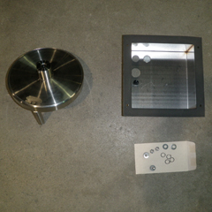 | 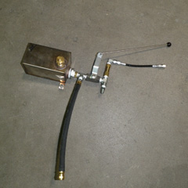 | 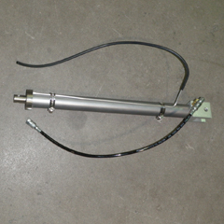 | 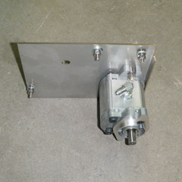 | 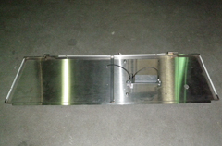
Handle, cover and fasteners | Hydraulic tank assembly | Hydraulic actuator assembly | Pump assembly | Front panel assembly

Notes
It is recommended that after the first step the unit be moved to an open area were access is available from all sides.

Warnings
This conversion should only be done by a qualified service technician.

Preparation

Tilt Pan. Remove safety thermostat from pan bottom  Lower pan back down to its cooking position.  Turn electrical and Gas supplies off.  Remove connections to the unit.  Move unit to an open area were you have access to all sides.  Remove right panel, rear panel, open front panel | 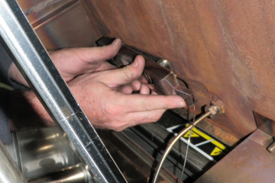

Disassembly

Disassembly and removal of electrical cover  Remove screws holding electrical box cover over controls  Remove orange and yellow wires going to motor  Remove RTD wires #9,10 on thermostat board  Remove safety thermostat |  | 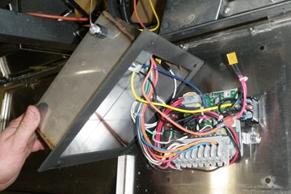
Remove wire harness  Label wires with reference to terminal block number in order to make reattachment easier.  Remove wires from terminal block.  Loosen liquid tight fitting, pull wires from cover.  Set cover aside | 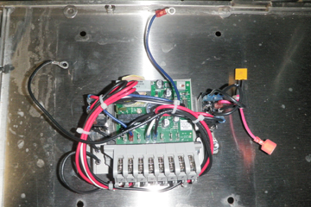
Remove and relocate Power switch  Disconnect wired from terminal block  Insert power switch into new front panel (indicator light facing top of panel). | 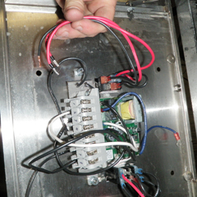
Remove and relocate terminal Block & thermostat
Remove screws holding terminal block
Remove wire from indicator light (#6) on terminal block
Remove dial
Remove nut from thermostat
Remove screws and pull board and off. Careful not to pull thermostat shaft out of board.

Relocate thermostat  Push on stop assembly  Push shaft through hole  Fasten board with 2 screws  Install sealing nut on shaft | 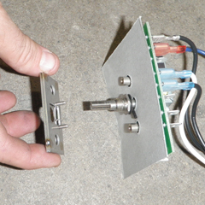Align stop assembly
Mount terminal block  Connect wires from power switch  Connect wire from indicator light | 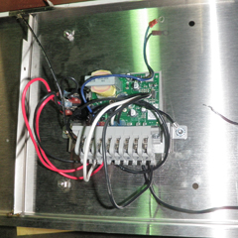Thermostat and terminal block remounted
Remove front Panel  May have to loosen hinge on frame in order to allow the panel hinge to pass the leg flange | 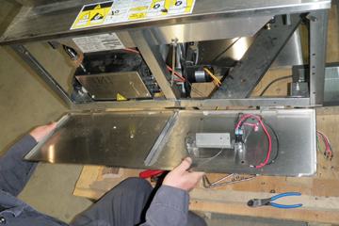
Remove actuator  Top pin first followed by bottom pin. | 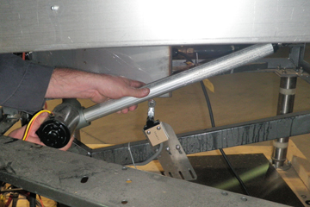
Disassembly complete

Reassembly

Hydraulic Actuator  Install new hydraulic ram using existing pins and new clips found in kit  Bottom first then top |  | 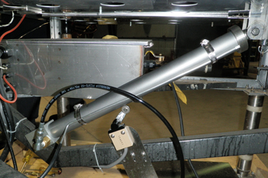
Pump Assembly  Remove mounting nuts and lock washers. Leave spacer in place.  Mount bracket on outside of frame using bottom bolt. Do not fully tighten.  Swivel into place and mount remaining 2 bolts  Tighten in place |  | 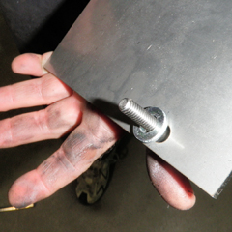  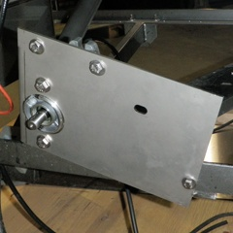
Hydraulic Tank  Mount tank to frame, 2 bolts  Connect hose from tank to pump  Connect hose from Actuator to tank  Connect second hose from tank to pump  Fill tank with oil |  | 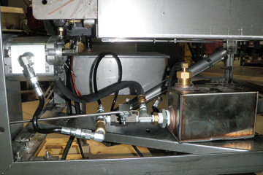
Add Oil  Turn intake elbow to up position (if not already)  Carefully pour in a little oil  Turn shaft 1/2 turn clockwise  Add more oil  Repeat a couple more times  Reconnect hose  Put on hand wheel and turn until oil runs out of bleed hole on Actuator |  | 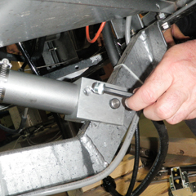  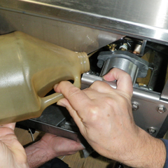
Bleed system  Install bleed nut  Raise pan up  Let pan down  Carefully open bleed screw until oil and air come out  Turn hand wheel ½ turn clockwise to expel more air.  Repeat process once more | 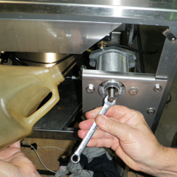
Checks
Check for oil leaks
Check oil level in tank
Reinstall safety thermostat  Using liquid tight fitting from original box install safety thermostat on to new cover  Raise pan  Add a small amount of silicone to seal hole  Run bulb up through heat shield and reinstall on pan plate  Lower pan  Remove hand wheel |  | 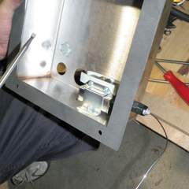
Front Panel  Install front panel  Retighten hinges  Mount panel support bracket |  | 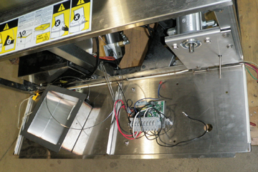

Wires  Mount conduit wire cable to cover  Mount RTD cable to cover  Connect blue and black wires from terminal block to safety thermostat  Reconnect 8 wires to terminal block  Connect RTD sensor wires to #9, 10 on board  Connect ground wire  Use tie wraps to neaten the wires | 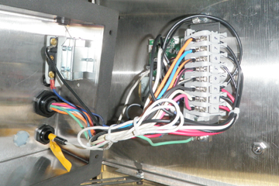
Install cover  Left Side- Remove nuts holding switch guard, drop box in place and install nuts.  Right side- install with hardware provided  Tie wrap safety thermostat tube to RTD sensor cable | 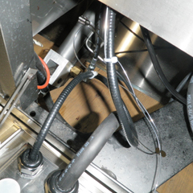
Final Assembly  Install side and back panels  Tilt front panel into position and install with trim piece  Screw knob onto push rod  Install hand wheel | 