Theory of Operation for
Glycol Chilled Equipment Loops.
This Glycol Chilled Equipment Loop consists of three main components:
1). Kitchen equipment (Cook Tank, Turbo Jet, Tumble chiller etc).
Kitchen equipment is the source of a heat load that is to be cooled. The piece of equipment is only included into the glycol cooling loop when it is set in a “Chilling Mode”.
2.) Glycol Tank – (GT):
This tank contains extra glycol and acts as a fluid buffer. It also has the circulating pump, bypass valve and glycol temperature controller onboard.
3.) Condenser Unit - Air or Water cooled – (CU):
This is means for cooling the glycol and removing heat from the system.
Normal Operation of System
During normal operation the two-(2) toggle switches inside of the Glycol Tank control panel will be switched to “RUN” and “STANDARD-STD,” see figure 1 below.

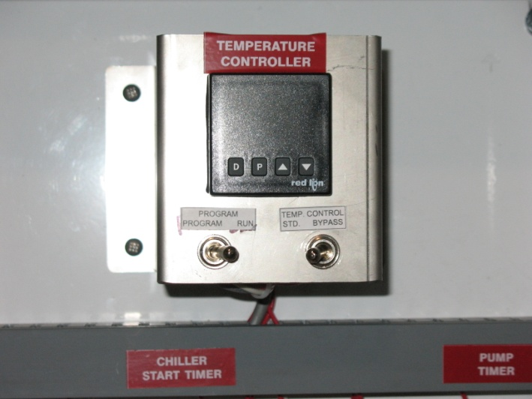

Figure 1

At any time when the Kitchen equipment is in a CHILLING MODE, a signal will be sent to the Glycol Tank to start the glycol circulation pump and the Condenser unit. The pump and CU will run continuously to maintain a glycol temperature sufficient for product cooling. The glycol will pump from the tank, through the CU then to the kitchen equipment and back again to the pump.
When the Kitchen equipment is no longer in the CHILLING MODE, the Glycol Tank goes into a “maintain” mode. During this mode, the GT will start and stop the pump and CU as needed to maintain a glycol temperature of 50 ° F. The glycol will travel in a loop between the GT and the CU only. The purpose of the “maintain” mode is to keep the glycol at a cool temperature at all times to be ready for product cooling.
If a problem occurs that allows the glycol temperature to rise above 95 deg F, the pump will stop and the CU will not be allowed to start. This fail safe feature is in place because the CU can become damaged if the incoming glycol exceeds 95 deg F. (Note: the Condenser unit has redundant protection and will shut itself off at this high temperature also). With the system stopped, the temperature should fall back within the proper range and the pump and CU will be allowed to start again.
Note: If the glycol temperature reaches the 95 deg top limit, there is likely a problem with the CU. It should be inspected to ensure that it has power and is in proper working order. The glycol Tank will continue to operate in the event that the CU is not powered up. For this reason, it is essential that the Condenser unit is powered on and ready anytime that the GT is.

Glycol Tank Bypass Switch Operation:

CAUTION: THIS SWITCH IS ONLY TO BE USED BY TRAINED SERVICE AGENTS. NEVER PUT THE GLYCOL TANK IN BYPASS WITHOUT READING THE INSTRUCTIONS BELOW.

The bypass switch allows a technician to bypass the temperature controller on the Glycol Tank to allow the pump to run regardless of glycol temperature. This is useful in the event that the glycol temperature exceeded the 95deg limit and needs to be cooled manually. Other than letting the system set for an extended period of time, bypass cooling is the only way to bring the glycol temperature back into the range acceptable for the refrigeration unit.
Before performing bypass cooling, be sure to find and correct the problem that caused the system to overheat.
To cool manually via Bypass Mode:
- Turn on kitchen equipment hooked to the glycol loop (cook tank, tumble chiller etc).
- Fill the equipment with cold water and put it into chill mode. Depending on how far above 95 deg the glycol is, ice may need to be added to the cold water in the tank.
- Switch the GT into bypass mode.
The pump will now circulate the glycol through the Condenser unit (which is not running) and the kitchen equipment. The cold water in the kitchen equipment will cool the glycol. When the glycol is between 50deg and 95 deg, remove the kitchen equipment from the chilling mode then switch the Glycol Tank back into “STANDARD” mode. This will resume normal operation of the glycol system. Assuming the original problem that lead to the overheating was solved; the system should go into stand by and hold the glycol temperature at 50 degrees F.

CAUTION: NEVER USE BYPASS MODE IF THE WATER INSIDE THE KITCHEN EQUIPMENT IS ABOVE ROOM TEMPERATURE.

