Easy Dial Datalogger Setup

Installing the Application
Plug in the flash drive to your computer/Laptop provided with the unit.
Open the flash drive, locate the “Easy Dial Datalogger Setup” file. Open this file.
Select “Repair Easy Dial Datalogger”
Click “Finish”
Running the application
Once installed, you will have an application icon i-e  setup on your destination folder or desktop. Open the EasyDial app. It will prompt you to the following page.
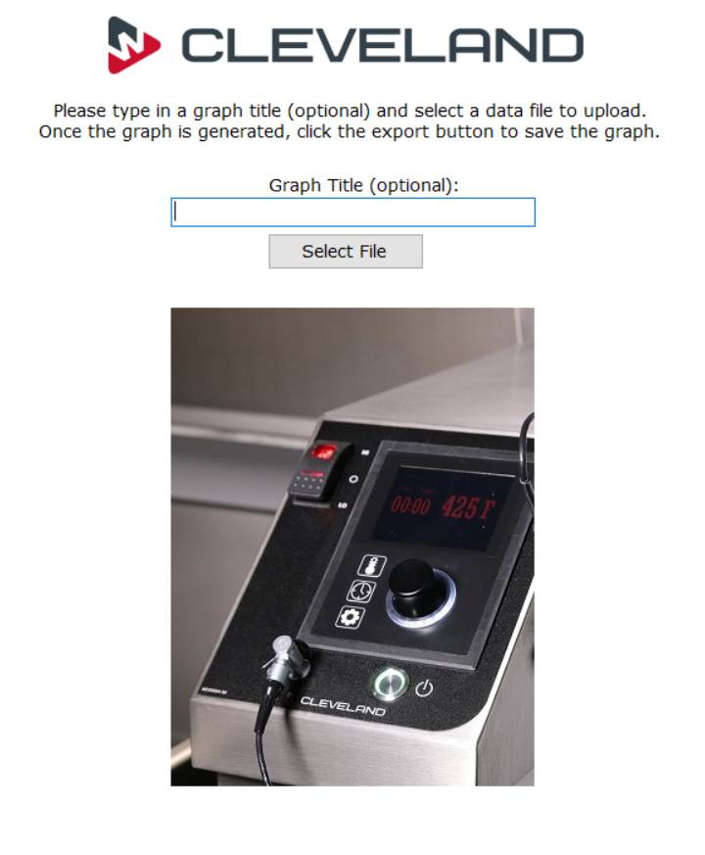
Select title (optional). Select file that you had transferred from datalogger to your flash drive. See datalogger documentation on how to transfer files from datalogger to the flash drive.
Once you have uploaded your file to the EasyDial app, you will be able to generate a graph between Temperature (Product Probe) and Time.

