22CET3.1 Condenser Box Old vs New

Cleveland does not make the old S111944; this has been discontinued even at the shift over from Ohio to Concord Cleveland. Hence, Concord Cleveland never developed this nor would have this part in stock.

Our current condenser box is one port 113895:
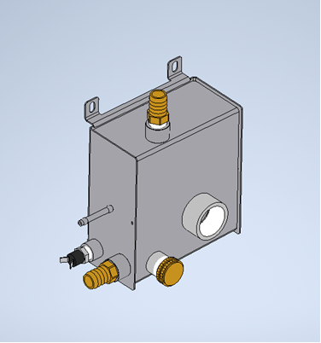

Overlaying the two models together, the bushing placements have been offset and injector style and overall design has been changed.
